**Lahore Garrison University**



**DATABASE MANAGEMENT SYSTEM**

**Project Report Review**

**Student Record Keeping Software**

**Team Members:**

[**Armoghan-ul-Mohmin**](https://github.com/Armoghan-ul-Mohmin) (Fa-21/BS DFCS/010)

Aftab Hussain (Fa-21/BS DFCS/033)

**Under the Guidance of: Imran Khalid & Saud Farooq**

**Department of Digital Forensics and Cyber Security, LGU**

**ABSTRACT:**

This project is basically creating a database management system for Student Record Keeping Software. Aim of the project is to creating a backend program of the processes taking place using SQL. This model deals with the relationship between Students, Teachers, Departments, and Exams. The other entities play a supportive weak role. So basically this helps the Students , Teachers and University to keep records.

**ER Diagram:**

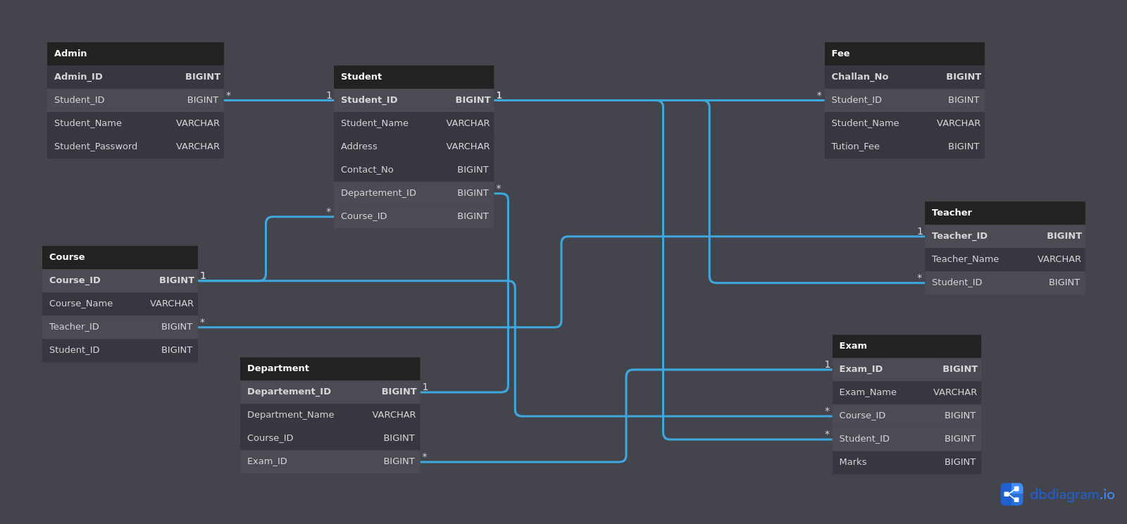

**Table:**

1. Admin
2. Student
3. Fee
4. Department
5. Course
6. Teacher
7. Exam

**Admin**

|  |  |  |
| --- | --- | --- |
| Attribute | Data type | Constraint |
| Admin_ID | Bigint | Primary Key |
| Student_ID | Varchar (20) | None |
| Student_Name | Varchar (20) | None |
| Student_Password | Varchar (20) |  |

**Student**

|  |  |  |
| --- | --- | --- |
| Attribute | Data type | Constraint |
| Student_ID | Bigint | None |
| Student _Name | Varchar (20) | Foreign Key |
| Address | Varchar (50) | None |
| Contant_No | Bigint | None |
| Department_ID | Bigint | None |
| Course_ID | Bigint | None |

**Teacher**

|  |  |  |
| --- | --- | --- |
| Attribute | Data type | Constraint |
| Teacher_ID | Bigint | Foreign Key |
| Teacher_Name | Varchar(20) | None |
| Student_ID | Bigint | None |

**Course Table**

|  |  |  |
| --- | --- | --- |
| Attribute | Data type | Constraint |
| Course_ID | Bigint | Foreign Key |
| Course_Name | Varchar(20) | None |
| Teacher_ID | Bigint | Foreign Key |
| Student_ID | Bigint |  |

**Department**

|  |  |  |
| --- | --- | --- |
| Attribute | Data type | Constraint |
| Department_ID | Bigint | Primary Key |
| Department_Name | Varchar(20) | None |
| Course_ID | Bigint | Foreign Key |
| Exam_ID | Bigint | Foreign Key |

**Exam**

|  |  |  |
| --- | --- | --- |
| Attribute | Data type | Constraint |
| Exam_ID | Bigint | Primary Key |
| Exam_Name | Varchar(20) | None |
| Course_ID | Bigint | Foreign Key |
| Student_ID | Bigint | Primary Key |
| Marks | Bigint | Primary Key |

**Fee Table**

|  |  |  |
| --- | --- | --- |
| Attribute | Data type | Constraint |
| Challan_No | Bigint | Primary Key |
| Student_ID | Bigint | None |
| Student_Name | Varchar(20) | Primary Key |
| Tution Fee | Bigint | Foreign Key |

**Code:**

IF NOT EXISTS

(SELECT * FROM sys.databases WHERE name = 'Project')

BEGIN

CREATE DATABASE Project;

END;

Use Project;

________________________________________________________________________________

-- Table Structure for Administartor Table.

IF NOT EXISTS (SELECT * FROM sysobjects WHERE name='Admin' )

CREATE TABLE Admin (

Admin_ID BIGINT Primary Key Not Null,

Student_ID BIGINT ,

Student_Name VARCHAR(20),

Student_Password VARCHAR(20),

CONSTRAINT Fk_Student_ID

FOREIGN KEY (Student_ID)

REFERENCES Student (Student_ID)

);

________________________________________________________________________________

-- Table Structure for Student Table.

IF NOT EXISTS (SELECT * FROM sysobjects WHERE name='Student' )

CREATE TABLE Student (

Student_ID BIGINT Primary Key Not Null,

Student_Name VARCHAR(20),

Address VARCHAR(50),

Contact_No BIGINT,

Departement_ID BIGINT,

Course_ID BIGINT,

CONSTRAINT Fk_Course_ID

FOREIGN KEY (Course_ID)

REFERENCES Course (Course_ID) ,

CONSTRAINT Fk_Departement_ID

FOREIGN KEY (Departement_ID)

REFERENCES Department (Departement_ID)

);

________________________________________________________________________________

-- Table Structure for Fee Table.

IF NOT EXISTS (SELECT * FROM sysobjects WHERE name='Fee' )

CREATE TABLE Fee (

Challan_No BIGINT Primary Key IDENTITY(1,1),

Student_ID BIGINT,

Student_Name VARCHAR(20),

Tution_Fee BIGINT ,

CONSTRAINT Fk_Student_ID

FOREIGN KEY (Student_ID)

REFERENCES Student (Student_ID),

CONSTRAINT Fk_Student_Name

FOREIGN KEY (Student_Name)

REFERENCES Student (Student_Name)

);

________________________________________________________________________________

-- Table Structure for Teacher Table.

IF NOT EXISTS (SELECT * FROM sysobjects WHERE name='Teacher' )

CREATE TABLE Teacher (

Teacher_ID BIGINT Primary Key Not Null,

Teacher_Name VARCHAR(20),

Student_ID BIGINT ,

CONSTRAINT Fk_Student_ID

FOREIGN KEY (Student_ID)

REFERENCES Student (Student_ID)

);

________________________________________________________________________________

-- Table Structure for Course Table.

IF NOT EXISTS (SELECT * FROM sysobjects WHERE name='Course' )

CREATE TABLE Course (

Course_ID BIGINT Primary Key Not Null,

Course_Name VARCHAR(20),

Teacher_ID BIGINT,

Student_ID BIGINT ,

CONSTRAINT Fk_Student_ID

FOREIGN KEY (Student_ID)

REFERENCES Student (Student_ID) ,

CONSTRAINT Fk_Teacher_ID

FOREIGN KEY (Teacher_ID)

REFERENCES Teacher (Teacher_ID)

);

________________________________________________________________________________

-- Table Structure for Department Table.

IF NOT EXISTS (SELECT * FROM sysobjects WHERE name='Department' )

CREATE TABLE Department (

Departement_ID BIGINT Primary Key Not Null,

Department_Name VARCHAR(20),

Course_ID BIGINT,

Exam_ID BIGINT ,

CONSTRAINT Fk_Course_ID

FOREIGN KEY (Course_ID)

REFERENCES Course (Course_ID)

);

________________________________________________________________________________

-- Table Structure for Exam Table.

IF NOT EXISTS (SELECT * FROM sysobjects WHERE name='Exam' )

CREATE TABLE Exam (

Exam_ID BIGINT Primary Key Not Null,

Exam_Name VARCHAR(20),

Course_ID BIGINT,

Student_ID BIGINT,

Marks BIGINT ,

CONSTRAINT Fk_Student_ID

FOREIGN KEY (Student_ID)

REFERENCES Student (Student_ID) ,

CONSTRAINT Fk_Course_ID

FOREIGN KEY (Course_ID)

REFERENCES Course (Course_ID)

);

________________________________________________________________________________

-- Dumping Data into Admin Table

INSERT INTO Admin

VALUES

(1 , 010 , 'Armoghan' , 'Armoghan_Password'),

(2 , 033 , 'Aftab Shah' , 'Aftab_Password');

________________________________________________________________________________

-- Dumping Data into Student Table

INSERT INTO Student

VALUES

(1 , 'Armoghan' , 'Lahore' , 03330000000 2 , 3 ),

(2 , 'Aftab Hussain' , 'Lahore' , 03330000001 2 , 3 );

________________________________________________________________________________

-- Dumping Data into Department Table

INSERT INTO Department

VALUES

(1 , 'Bs CS' , 1 , 3 ),

(2 , 'Bs IT' , 3 , 2),

(3 , 'Bs DFCS' , 2 , 1 );

________________________________________________________________________________

-- Dumping Data into Teacher Table

INSERT INTO Teacher

VALUES

(1 , 'Imran Khalid' , 2 ),

(2 , 'Saud Bin Farooq' , 1 );

________________________________________________________________________________

-- Dumping Data into Fee Table

INSERT INTO Fee ( Student_Id , Student_Name , Tution_Fee)

VALUES

(1 , 'Armoghan' , 50000 ),

(2 , 'Afta Hussain' , 50000 );

________________________________________________________________________________

-- Dumping Data into Exam Table

INSERT INTO Exam

VALUES

(1 , 'Mids' , 1 , 1 , 80 ),

(2 , 'Finals' , 2 , 1 , 80 );

________________________________________________________________________________

-- Dumping Data into Course Table

INSERT INTO Course

VALUES

(1 , 'Fa-21' , 1 , 2 ),

(2 , 'Sp-21' , 2 , 1 );

________________________________________________________________________________

-- Procedure to Print Admin Table

CREATE PROCEDURE Admin_Table

AS

SELECT * FROM Admin

________________________________________________________________________________

-- Procedure to Print Student Table

CREATE PROCEDURE Student_Table

AS

SELECT * FROM Student

________________________________________________________________________________

-- Procedure to Print Fee Table

CREATE PROCEDURE Fee_Table

AS

SELECT * FROM Fee

________________________________________________________________________________

-- Procedure to Print Course Table

CREATE PROCEDURE Course_Table

AS

SELECT * FROM Course

________________________________________________________________________________

-- Procedure to Print Department Table

CREATE PROCEDURE Department_Table

AS

SELECT * FROM Department

________________________________________________________________________________

-- Procedure to Print Teacher Table

CREATE PROCEDURE Teacher_Table

AS

SELECT * FROM Teacher

________________________________________________________________________________

-- Procedure to Print Exam Table

CREATE PROCEDURE Exam_Table

AS

SELECT * FROM Exam

________________________________________________________________________________

EXEC Admin_Table

EXEC Student_Table

EXEC Fee_Table

EXEC Course_Table

EXEC Department_Table

EXEC Teacher_Table

EXEC Exam_Table

Project Details: https://github.com/Armoghan-ul-Mohmin/Student-Record-Keeping-System